**Eric Webb**

**Final Project Description and Requirements**

**MSIT 630 Database Systems (Summer 2019)**

**Total: 36 points**

**Due date: 7/28/2019 11:59PM**

**Project Report**

**Description.**

This is a database for a music application. This application will hold users, songs, artist, and playlists. Users can add songs to their playlists and the playlists will hold the songs id. Many users can have many playlists. Many Playlists can have multiple songs. One song can only belong to one album. One song can only belong to one artist. One artist can have many songs. The database language is MySQL and is hosted was hosted on Amazon Web Services.

**Design and Implementation**

**E-R Diagram.**

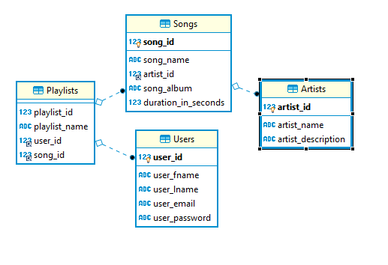

**Users**

The **primary key** “user_id” will be an auto incrementing integer with a not null constraint.

Users will have a “user_fname” which will be a varchar max of 20 characters and a not null constraint.

Users will have a “user_lname” which will be a varchar max of 20 characters and a not null constraint.

Users will have an “email” which will be a varchar max of 20 characters and a not null constraint.

Users will have a “password” which will be a varchar max of 20 characters and a not null constraint.

One user can have many playlists. This is a one to many relationship.

This table is in 3rd normal form.

**create** **table** **if** **not** **EXISTS** Users(

user_id **INT** **NOT** **NULL** **AUTO_INCREMENT**,

user_fname **VARCHAR**(20) **NOT** **NULL**,

user_lname **VARCHAR**(20) **NOT** **NULL**,

user_email **VARCHAR**(20) **NOT** **NULL**,

user_password **VARCHAR**(20) **NOT** **NULL**,

**PRIMARY** **KEY** ( user_id )

)ENGINE INNODB;

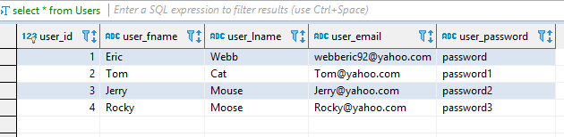

**Artists**

The **primary key** “artist_id” will be an auto incrementing integer with a not null constraint.

Artists will have a “name” which will be a varchar max of 20 characters and a not null constraint.

Artists will have a “description” which will be a varchar max of 60 characters and a not null constraint.

This table is in 3rd normal form.

**create** **table** **if** **not** **EXISTS** Artists(

artist_id **INT** **NOT** **NULL** **AUTO_INCREMENT**,

artist_name **VARCHAR**(20) **NOT** **NULL**,

artist_description **VARCHAR**(60) **NOT** **NULL**,

**PRIMARY** **KEY** ( artist_id )

)ENGINE INNODB;

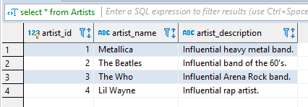

**Songs**

The **primary key** “song_id” will be an auto incrementing integer with a not null constraint.

Songs will have a “song_name” which will be a varchar max of 50 characters and a not null constraint.

Songs will have a **foreign key** “artist_id” which will be an integer with a not null constraint.

Songs will have a “song_album” which will be a varchar max of 50 characters and a not null constraint.

Songs will have a “duration_in_seconds” which will be an integer with a not null constraint.

One song can have one Artist, this is a one-to-one relationship.

This table is in third normal form.

**create** **table** **if** **not** **EXISTS** Songs(

song_id **INT** **NOT** **NULL** **AUTO_INCREMENT**,

song_name **VARCHAR**(50) **NOT** **NULL**,

artist_id **INT** **NOT** **NULL**,

song_album **VARCHAR**(50) **NOT** **NULL**,

duration_in_seconds **INT** **NOT** **NULL**,

**PRIMARY** **KEY** ( song_id ),

**FOREIGN** **KEY** artist_id(artist_id)

**REFERENCES** Artists(artist_id)

**ON** **UPDATE** **CASCADE**

**ON** **DELETE** **RESTRICT**

)ENGINE INNODB;

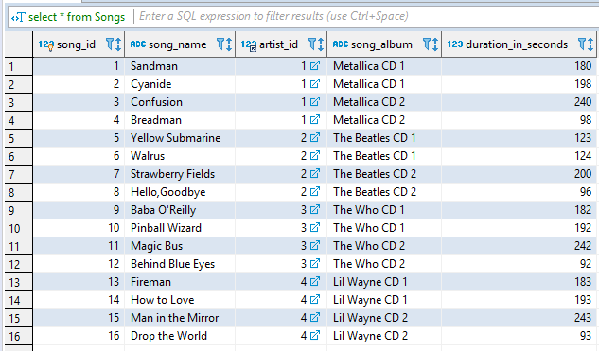

**Playlists**

The **primary key** “playlist_id” will be an auto incrementing integer with a not null constraint.

Playlists will have a “playlist_ name” which will be a varchar max of 50 characters and a not null constraint.

Playlists will have a **foreign key** “user_id” which will be an integer with a not null constraint.

Playlists will have a **foreign key** “song_id” which will be an integer with a not null constraint.

Many playlists can have many songs. This is a many to many relationship.

This table is in 3rd normal form.

**create** **table** **if** **not** **EXISTS** Playlists(

playlist_id **INT** **NOT** **NULL**,

playlist_name **VARCHAR**(50) **NOT** **NULL**,

user_id **int** **NOT** **NULL**,

song_id **INT** **NOT** **NULL**,

**FOREIGN** **KEY** user_id(user_id)

**REFERENCES** Users(user_id)

**ON** **UPDATE** **CASCADE**

**ON** **DELETE** **RESTRICT**,

**FOREIGN** **KEY** song_id(song_id)

**REFERENCES** Songs(song_id)

**ON** **UPDATE** **CASCADE**

**ON** **DELETE** **RESTRICT**

)ENGINE INNODB;

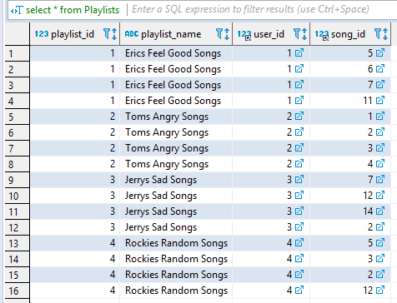

**Queries**

**Multi-table queries;**

1. This query returns all the songs from Eric’s playlists.

**select** **DISTINCT** Songs.song_id,Songs.song_name **from** Songs, Playlists **where** Songs.song_id = Playlists.song_id **and** Playlists.playlist_name = "Erics Feel Good Songs" ;

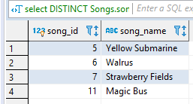

1. This query returns the users and playlists that have Metallica’s Cyanide song except for Tom’s playlist. This query also uses a group by having.

**select** **DISTINCT** Users.user_fname,Users.user_lname,Playlists.playlist_name,Songs.song_name **from** Users,Playlists,Songs **where** Playlists.user_id = Users.user_id **and** Playlists.song_id =2 **group** **by** Users.user_fname **having** **not** user_fname= "Tom";

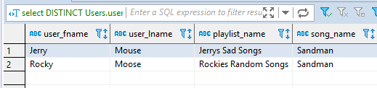

**Aggregate function queries;**

1. This query returns the average time of all songs in each album

**SELECT** song_album,**AVG**(duration_in_seconds) **as** avgTime **FROM** Songs **group** **by** song_album;

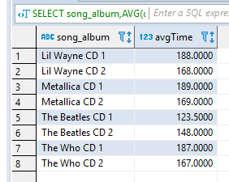

1. This query returns the average time of all songs in each album having greater than the average time of the songs in Metallica’s second CD. This Query is also has a sub query and uses group by having.

**SELECT** song_album,**AVG**(duration_in_seconds) **as** avgTime **FROM** Songs **group** **by** song_album **having** avgTime > (**select** **AVG**(duration_in_seconds)**from** Songs **where** song_album = "Metallica CD 2");

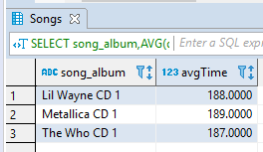

**Sub-query;**

1. This query returns the minimum song on all albums who are longer than the minimum song from Metallica (98 seconds.)

**select** song_album,song_name, **min**(duration_in_seconds)**as** minAlbumSongTime **from** Songs **group** **by** song_album **having** minAlbumSongTime > (**select** **min**(duration_in_seconds) **from** Songs **where** artist_id = 1);

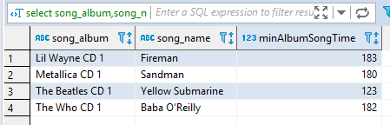

**NULL query;**

1. This query returns all playlists from playlist ID where playlist ID in Not Null. (Returns all.)

**select** **distinct** playlist_id,playlist_name **from** Playlists **where** playlist_id **is** **not** **null**;

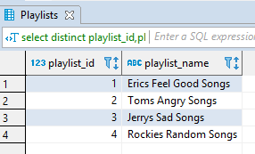

**Complete list of statements.**

**drop** **table** **if** **exists** Users;

**create** **table** **if** **not** **EXISTS** Users(

user_id **INT** **NOT** **NULL** **AUTO_INCREMENT**,

user_fname **VARCHAR**(20) **NOT** **NULL**,

user_lname **VARCHAR**(20) **NOT** **NULL**,

user_email **VARCHAR**(20) **NOT** **NULL**,

user_password **VARCHAR**(20) **NOT** **NULL**,

**PRIMARY** **KEY** ( user_id )

)ENGINE INNODB;

**drop** **table** **if** **exists** Artists;

**create** **table** **if** **not** **EXISTS** Artists(

artist_id **INT** **NOT** **NULL** **AUTO_INCREMENT**,

artist_name **VARCHAR**(20) **NOT** **NULL**,

artist_description **VARCHAR**(60) **NOT** **NULL**,

**PRIMARY** **KEY** ( artist_id )

)ENGINE INNODB;

**drop** **table** **if** **exists** Songs;

**create** **table** **if** **not** **EXISTS** Songs(

song_id **INT** **NOT** **NULL** **AUTO_INCREMENT**,

song_name **VARCHAR**(50) **NOT** **NULL**,

artist_id **INT** **NOT** **NULL**,

song_album **VARCHAR**(50) **NOT** **NULL**,

duration_in_seconds **INT** **NOT** **NULL**,

**PRIMARY** **KEY** ( song_id ),

**FOREIGN** **KEY** artist_id(artist_id)

**REFERENCES** Artists(artist_id)

**ON** **UPDATE** **CASCADE**

**ON** **DELETE** **RESTRICT**

)ENGINE INNODB;

**drop** **table** **if** **exists** Playlists;

**create** **table** **if** **not** **EXISTS** Playlists(

playlist_id **INT** **NOT** **NULL**,

playlist_name **VARCHAR**(50) **NOT** **NULL**,

user_id **int** **NOT** **NULL**,

song_id **INT** **NOT** **NULL**,

**FOREIGN** **KEY** user_id(user_id)

**REFERENCES** Users(user_id)

**ON** **UPDATE** **CASCADE**

**ON** **DELETE** **RESTRICT**,

**FOREIGN** **KEY** song_id(song_id)

**REFERENCES** Songs(song_id)

**ON** **UPDATE** **CASCADE**

**ON** **DELETE** **RESTRICT**

)ENGINE INNODB;

**insert** **into** Users ( user_fname,user_lname,user_email,user_password)

**values**

("Eric","Webb","webberic92@yahoo.com","password"),

("Tom","Cat","Tom@yahoo.com","password1"),

("Jerry","Mouse","Jerry@yahoo.com","password2"),

("Rocky","Moose","Rocky@yahoo.com","password3");

**insert** **into** Artists (artist_name,artist_description)

**values**

("Metallica","Influential heavy metal band."),

("The Beatles","Influential band of the 60's."),

("The Who","Influential Arena Rock band."),

("Lil Wayne","Influential rap artist.");

**insert** **into** Songs (song_name,artist_id,song_album,duration_in_seconds)

**values**

("Sandman",1,"Metallica CD 1", 180),

("Cyanide",1,"Metallica CD 1", 198),

("Confusion",1,"Metallica CD 2", 240),

("Breadman",1,"Metallica CD 2", 98),

("Yellow Submarine",2,"The Beatles CD 1", 123),

("Walrus",2,"The Beatles CD 1", 124),

("Strawberry Fields",2,"The Beatles CD 2", 200),

("Hello,Goodbye",2,"The Beatles CD 2", 96),

("Baba O'Reilly",3,"The Who CD 1", 182),

("Pinball Wizard",3,"The Who CD 1", 192),

("Magic Bus",3,"The Who CD 2", 242),

("Behind Blue Eyes",3,"The Who CD 2", 92),

("Fireman",4,"Lil Wayne CD 1", 183),

("How to Love",4,"Lil Wayne CD 1", 193),

("Man in the Mirror",4,"Lil Wayne CD 2", 243),

("Drop the World",4,"Lil Wayne CD 2", 93)

;

**insert** **into** Playlists (playlist_id,playlist_name,user_id,song_id)

**VALUES**

(1,"Erics Feel Good Songs",1,5),

(1,"Erics Feel Good Songs",1,6),

(1,"Erics Feel Good Songs",1,7),

(1,"Erics Feel Good Songs",1,11),

(2,"Toms Angry Songs",2,1),

(2,"Toms Angry Songs",2,2),

(2,"Toms Angry Songs",2,3),

(2,"Toms Angry Songs",2,4),

(3,"Jerrys Sad Songs",3,7),

(3,"Jerrys Sad Songs",3,12),

(3,"Jerrys Sad Songs",3,14),

(3,"Jerrys Sad Songs",3,2),

(4,"Rockies Random Songs",4,5),

(4,"Rockies Random Songs",4,3),

(4,"Rockies Random Songs",4,2),

(4,"Rockies Random Songs",4,12);

**select** * **from** Users;

**select** * **from** Artists;

**select** * **from** Songs;

**select** * **from** Playlists;

**select** **DISTINCT** Songs.song_id,Songs.song_name **from** Songs, Playlists **where** Songs.song_id = Playlists.song_id **and** Playlists.playlist_name = "Erics Feel Good Songs" ;

**select** **DISTINCT** Users.user_fname,Users.user_lname,Playlists.playlist_name,Songs.song_name **from** Users,Playlists,Songs **where** Playlists.user_id = Users.user_id **and** Playlists.song_id =2 **group** **by** Users.user_fname **having** **not** user_fname= "Tom";

**SELECT** song_album,**AVG**(duration_in_seconds) **as** avgTime **FROM** Songs **group** **by** song_album;

**SELECT** song_album,**AVG**(duration_in_seconds) **as** avgTime **FROM** Songs **group** **by** song_album **having** avgTime > (**select** **AVG**(duration_in_seconds)**from** Songs **where** song_album = "Metallica CD 2");

**select** song_album,song_name, **min**(duration_in_seconds)**as** minAlbumSongTime **from** Songs **group** **by** song_album **having** minAlbumSongTime > (**select** **min**(duration_in_seconds) **from** Songs **where** artist_id = 1);

**select** **distinct** playlist_id,playlist_name **from** Playlists **where** playlist_id **is** **not** **null**;